Patrick Griffin

2/17/17

Class Participation #2

***ScoreRater.cpp***

Output for ScoreRater.cpp

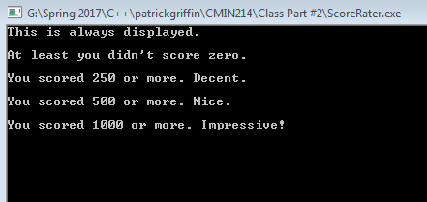

***ScoreRater2.0.cpp***

Input 1 for ScoreRater2.0.cpp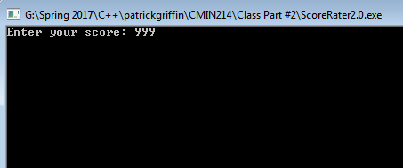

Output 1 for ScoreRater2.0.cpp 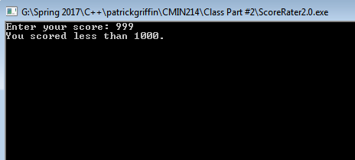

Input 2 for ScoreRater2.0.cpp 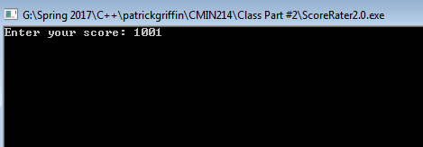

Output 2 for ScoreRater2.0.cpp 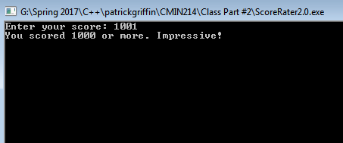

***ScoreRater3.0.cpp***

Input 1 for ScoreRater3.0.cpp 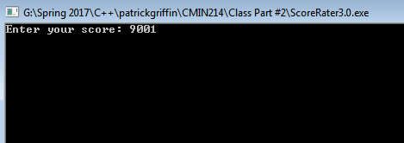

Output 1 for ScoreRater3.0.cpp

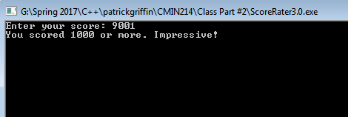

Input 2 for ScoreRater3.0.cpp 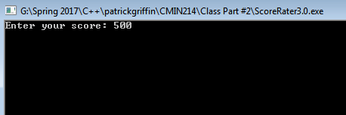

Input 2 for ScoreRater3.0.cpp 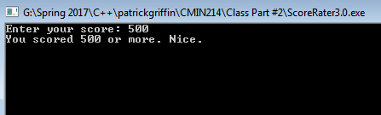

Input 3 for ScoreRater3.0.cpp 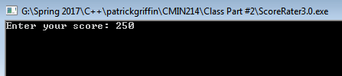

Output 3 for ScoreRater3.0.cpp 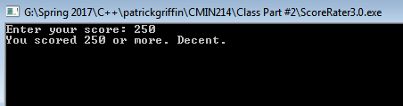

Input 4 for ScoreRater3.0.cpp 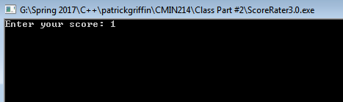

Output 4 for ScoreRater3.0.cpp 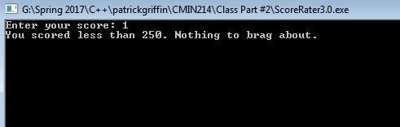

***MenuChooser.cpp***

Input and output of choices 1 through 4 for MenuChooser.cpp

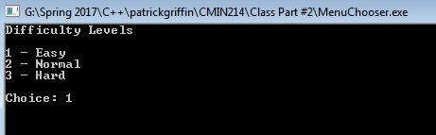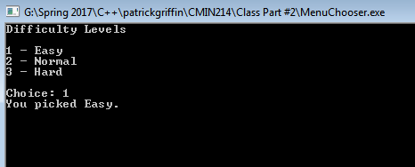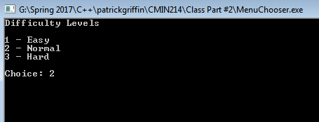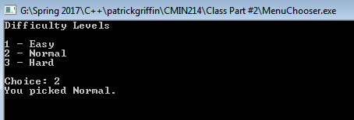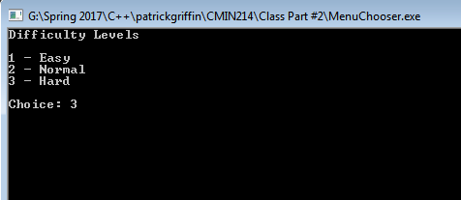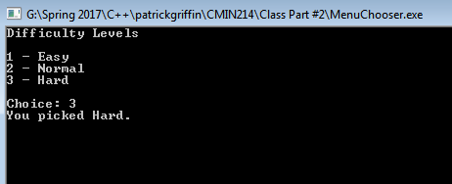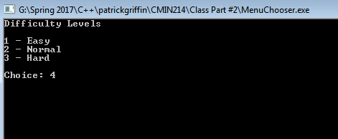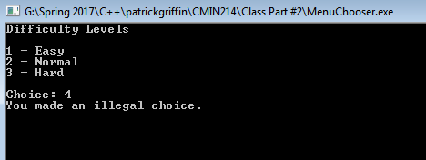

***PlayAgain.cpp***

Input and output of y and n for PlayAgain.cpp

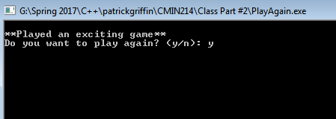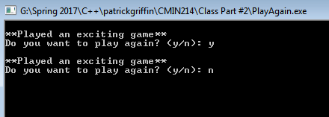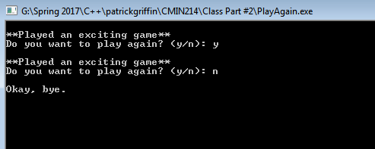

***PlayAgain2.0.cpp***

Input and output of y and n for PlayAgain2.0.cpp

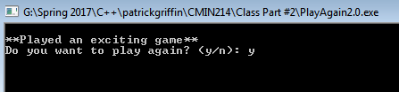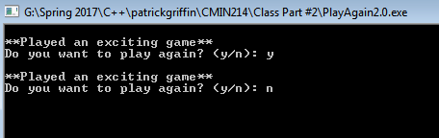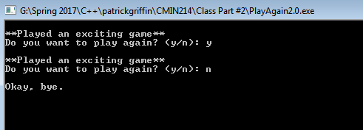

***FinickyCounter.cpp***

Output for FinickyCounter.cpp

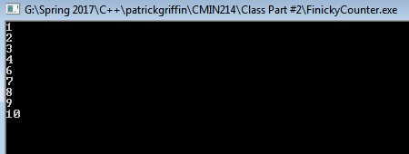

***DesignersNetwork.cpp***

Input and output of usernames and passwords for DesignersNetwork.cpp

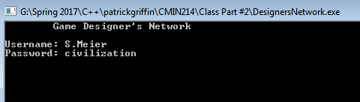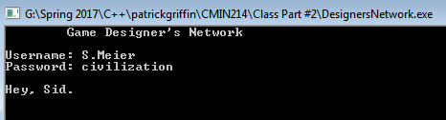

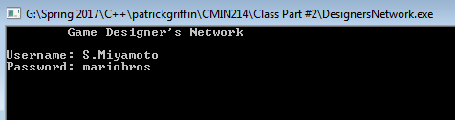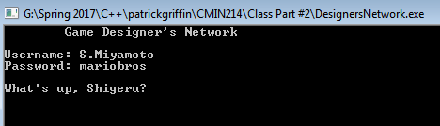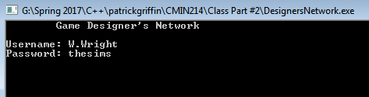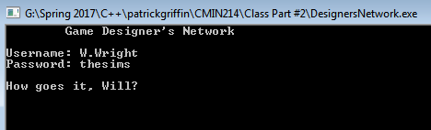

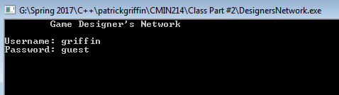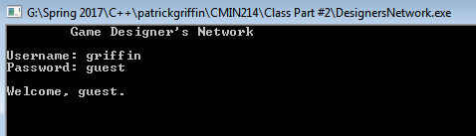

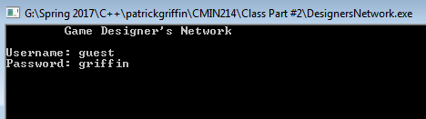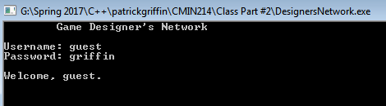

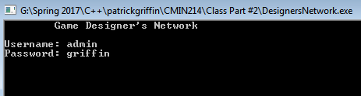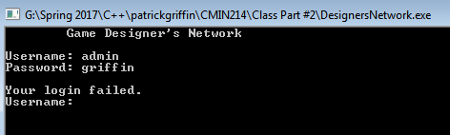

***DieRoller.cpp***

Output of two rolls for DieRoller.cpp

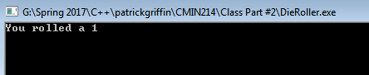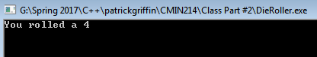

***GuessMyNumber.cpp***

Input and output of all guesses for GuessMyNumber.cpp

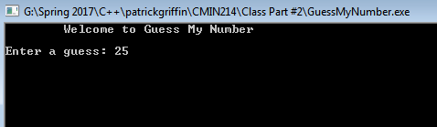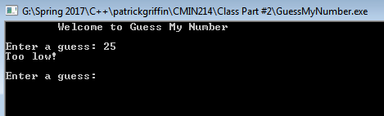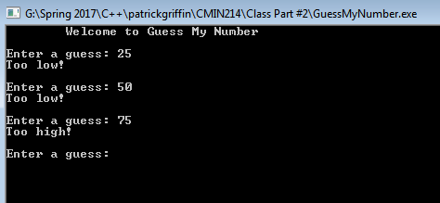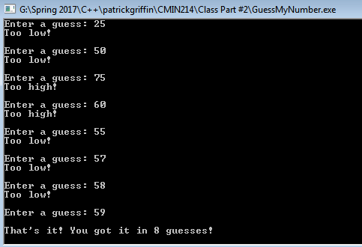

***ScoreRater4.0.cpp***

All input and output for ScoreRater4.0.cpp

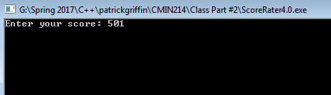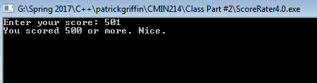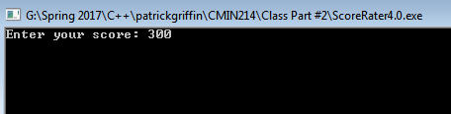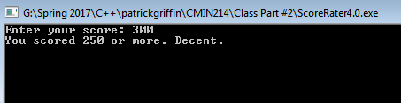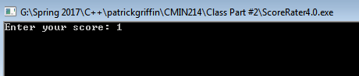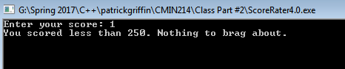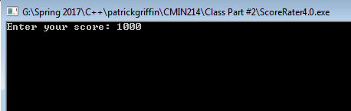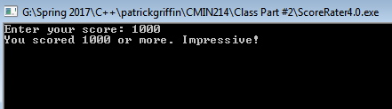

***GuessMyNumber2.0.cpp***

Input and output of GuessMyNumber2.0.cpp

